Create a Virtual Machine

While creating VM Select Disk tab

Select UnManaged Disk

It will ask to create a Storage Account

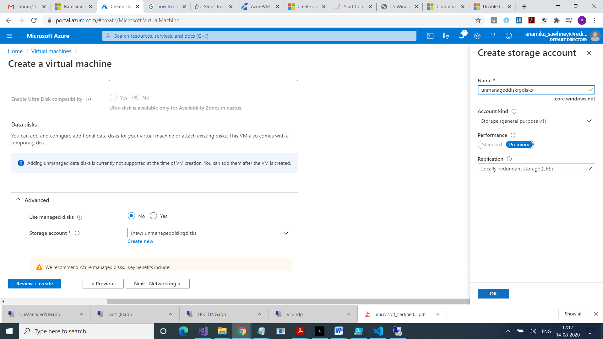

Add Extension : in case you want to install IIS on the VM, otherwise skip

For this you will need to add a storage account

Inside that add a container, and upload script file .It will take some time to do all these things.

You will see in VM

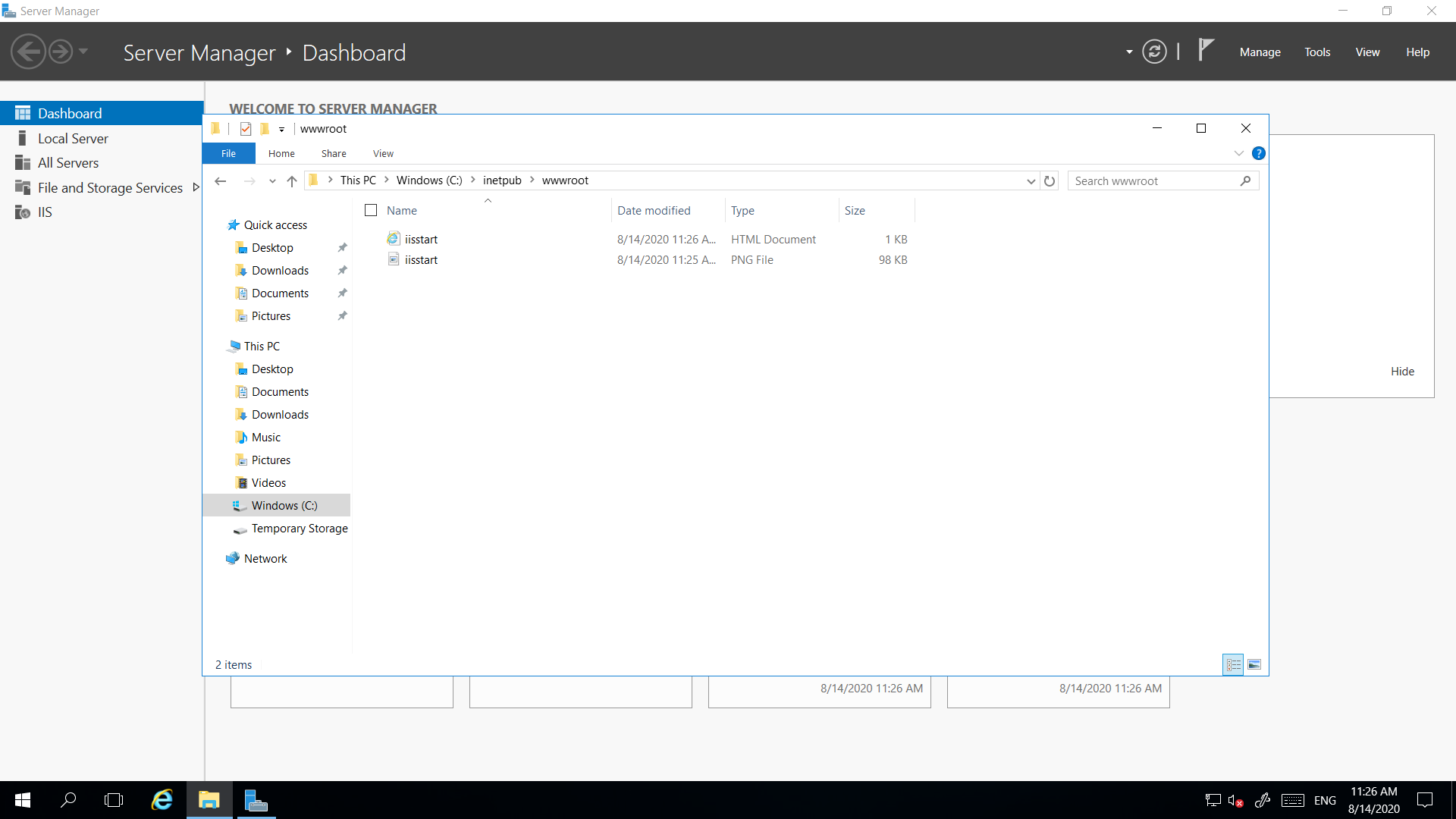

Unmanaged Disk

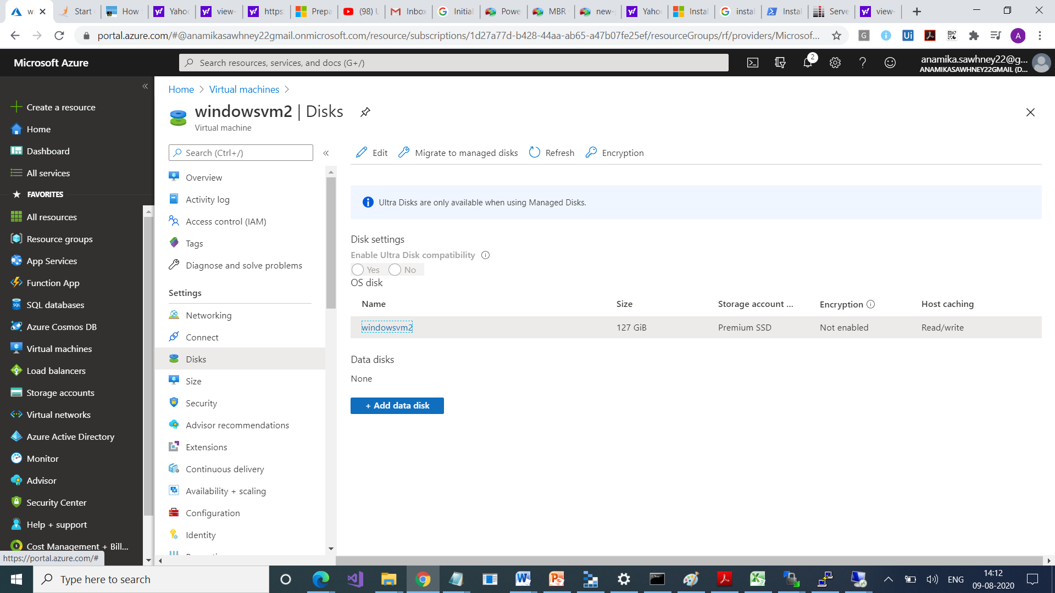

Check in Browser

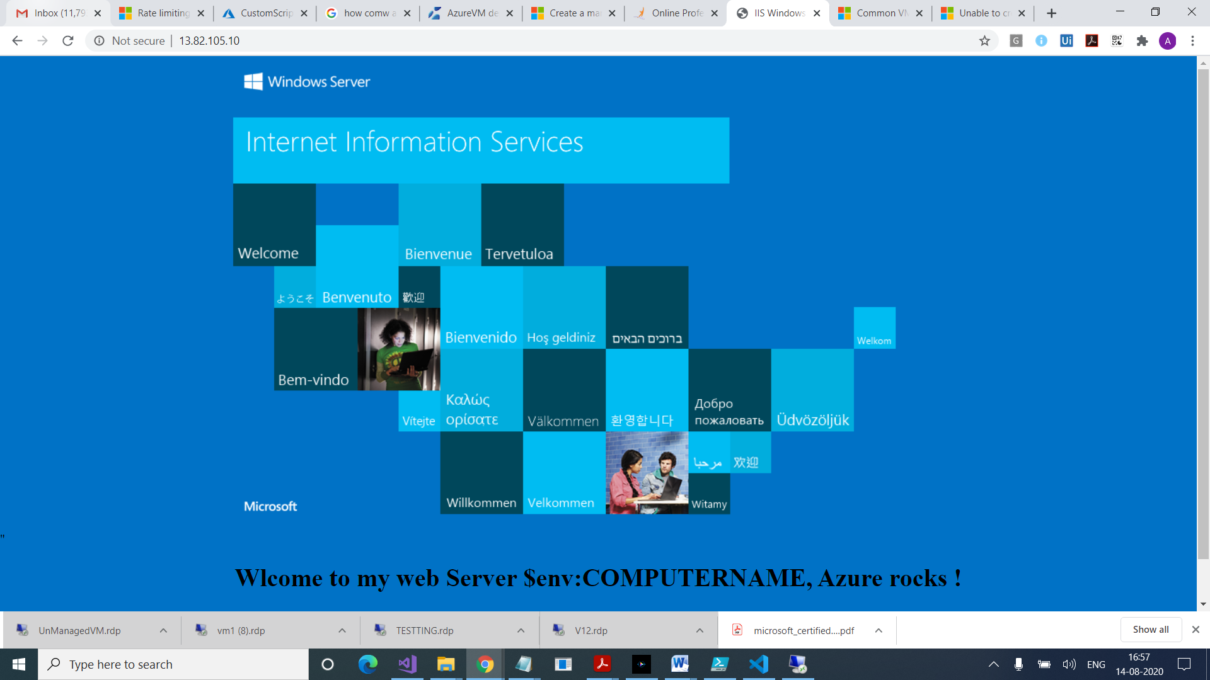

Add a data disk

Go to Azure Portal

Go to VM

Click on Add Data Disk

It will show Attach Unmanaged Disk

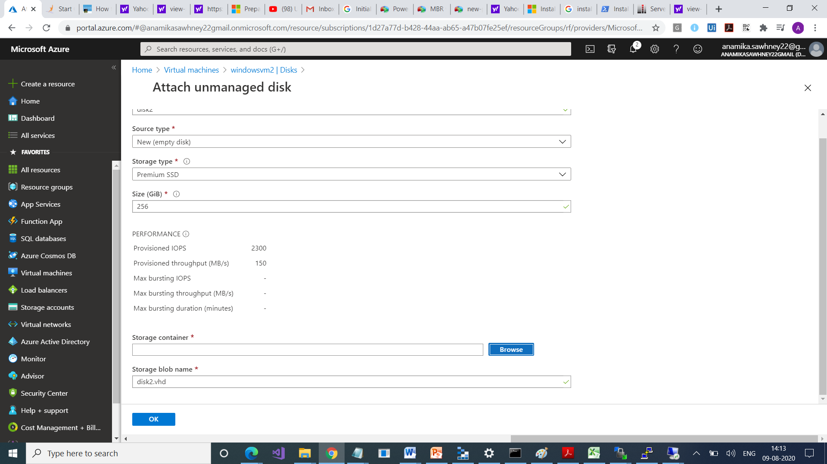

Select Storage Account

Select Container vhds

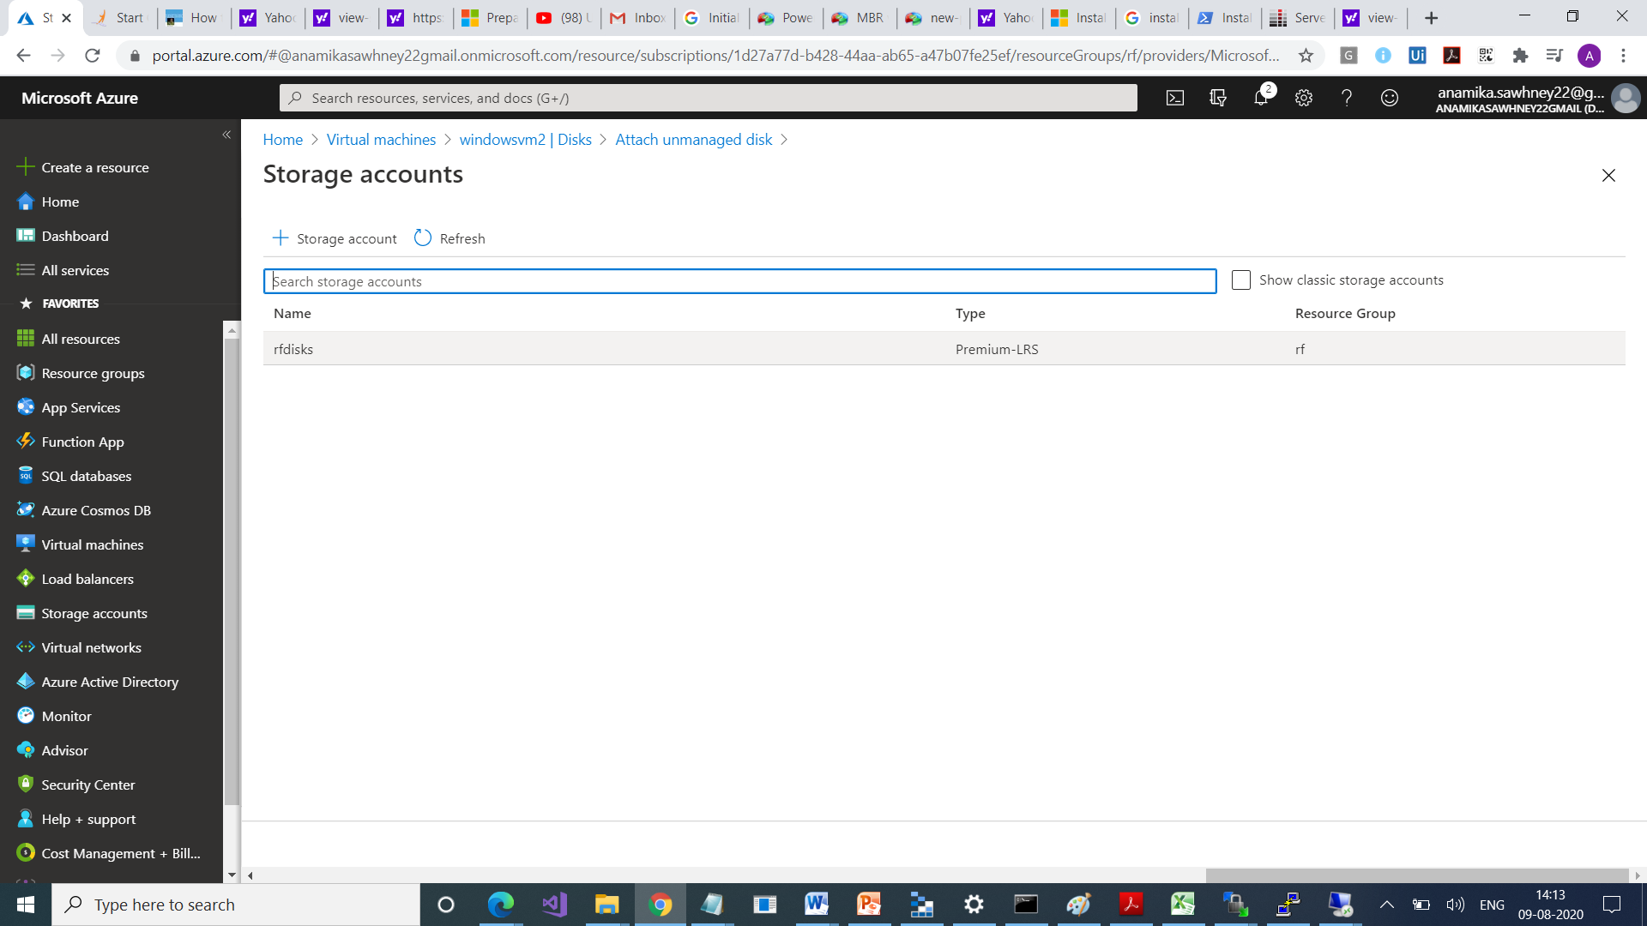

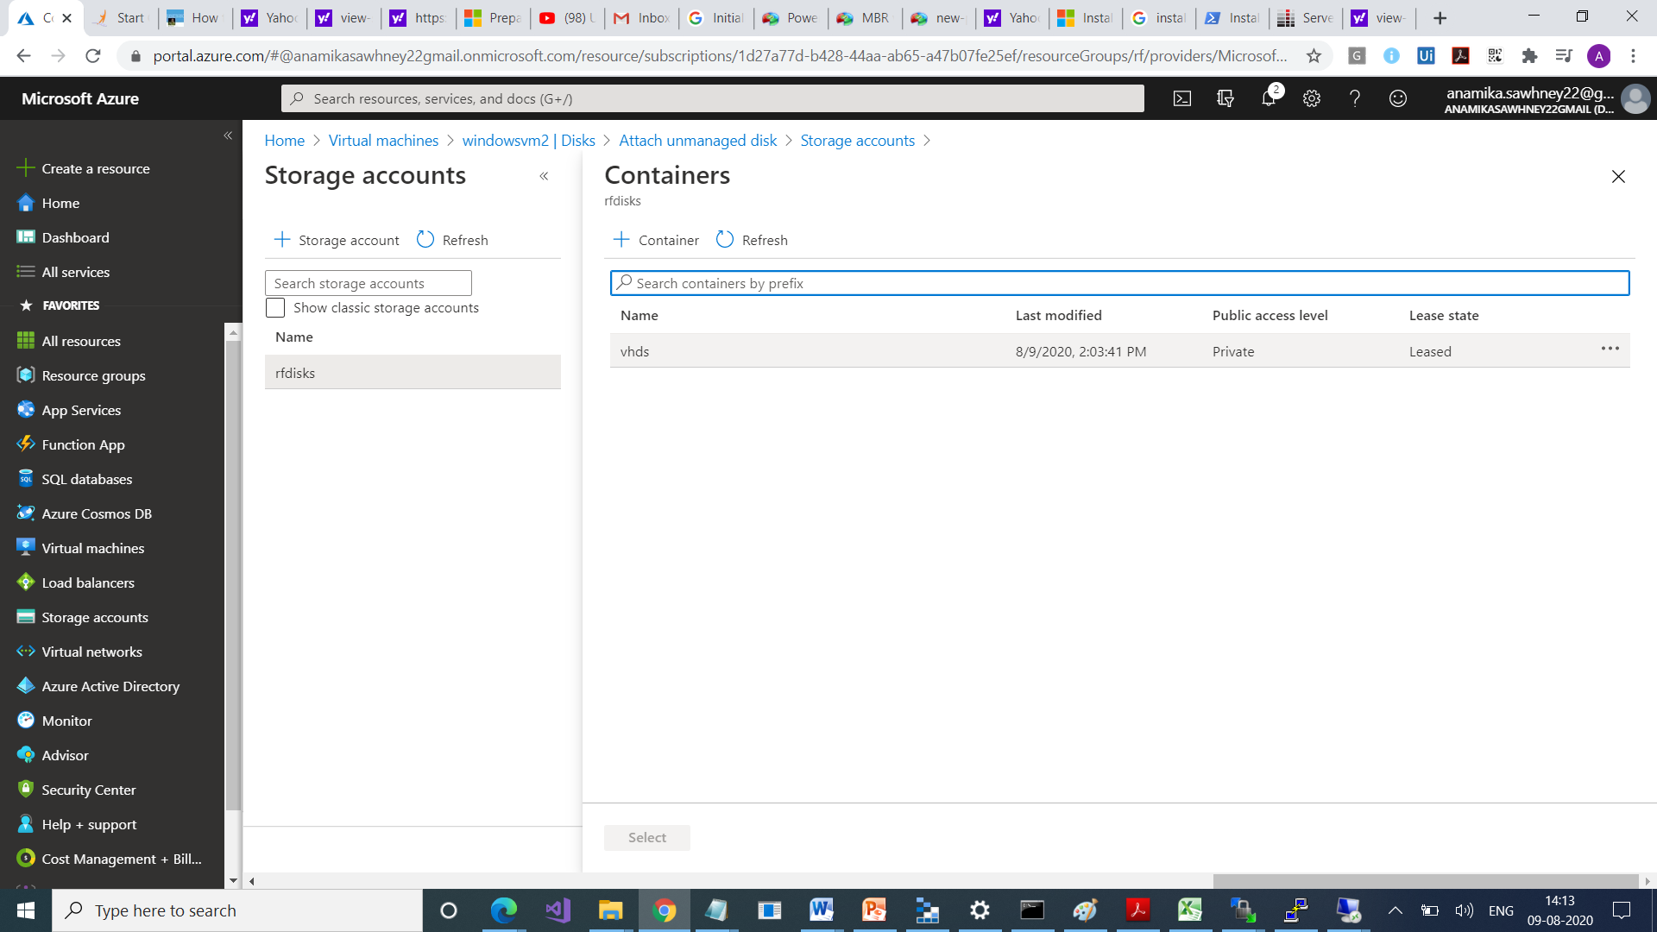

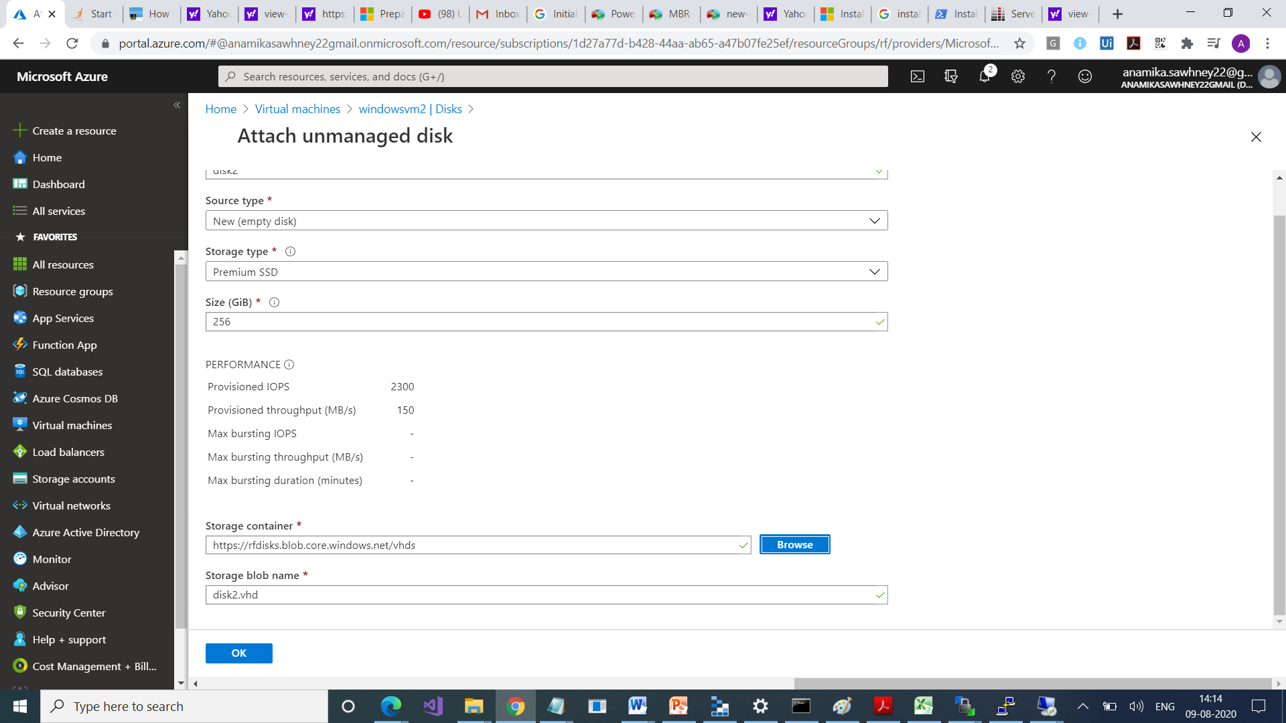

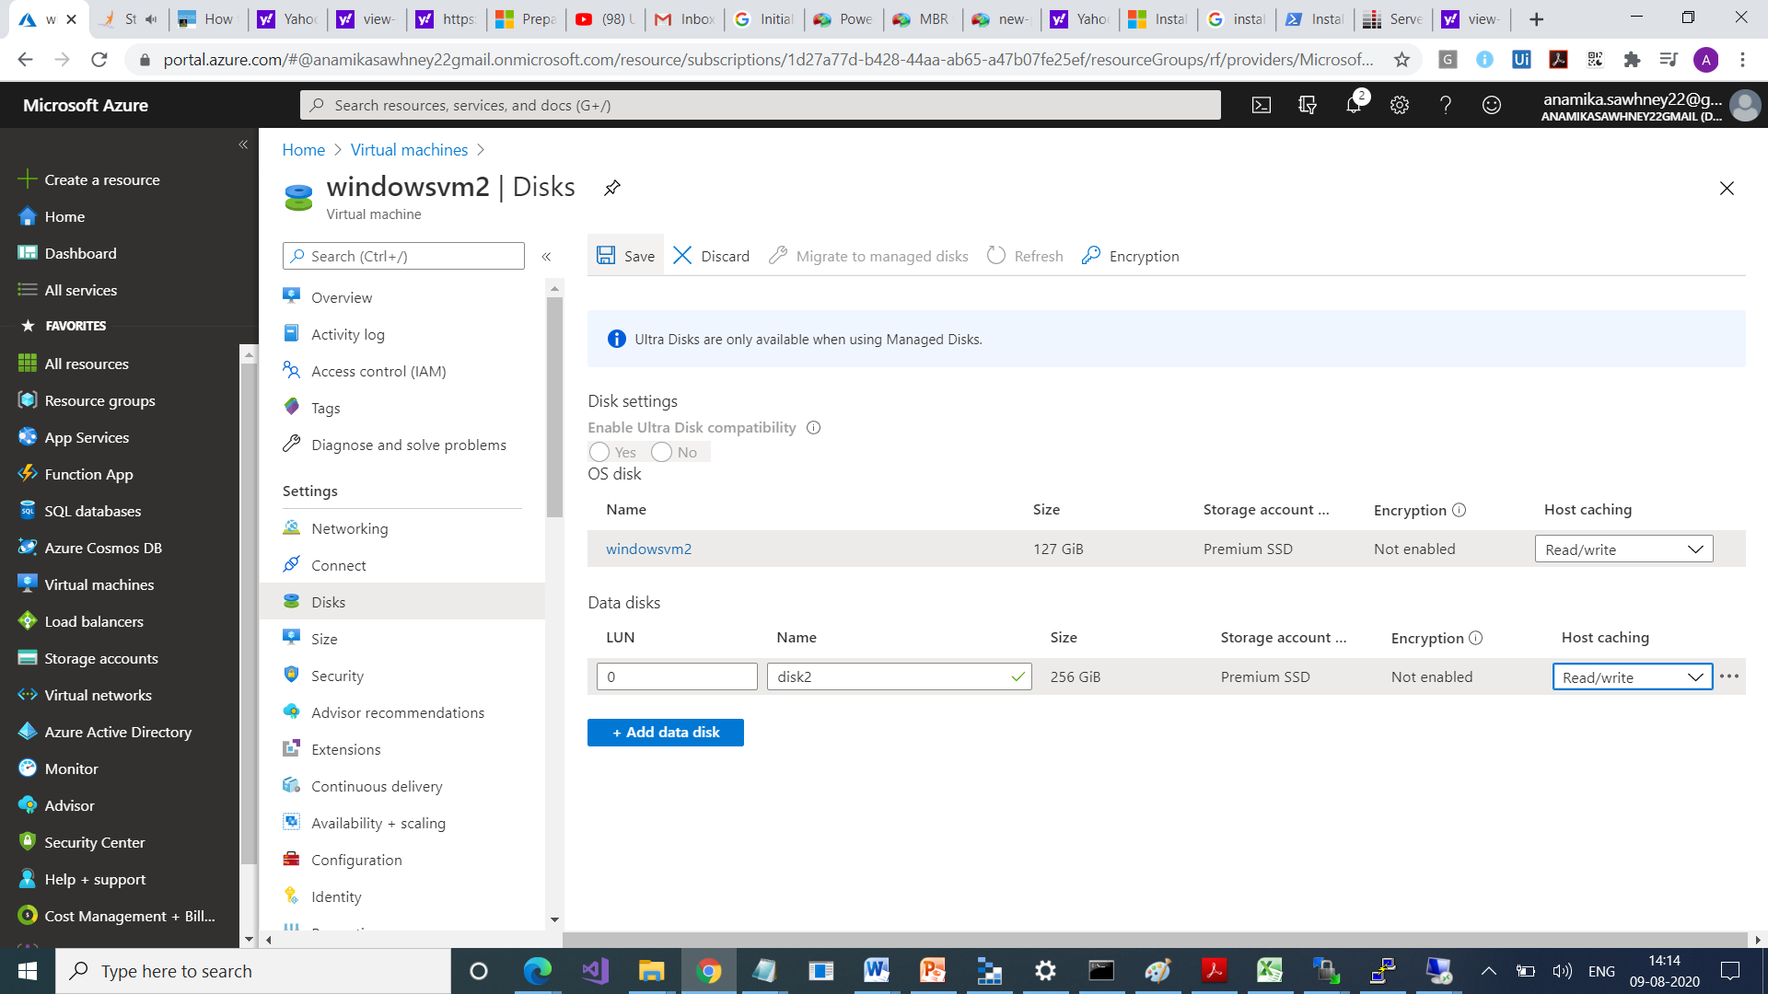

Go to VM

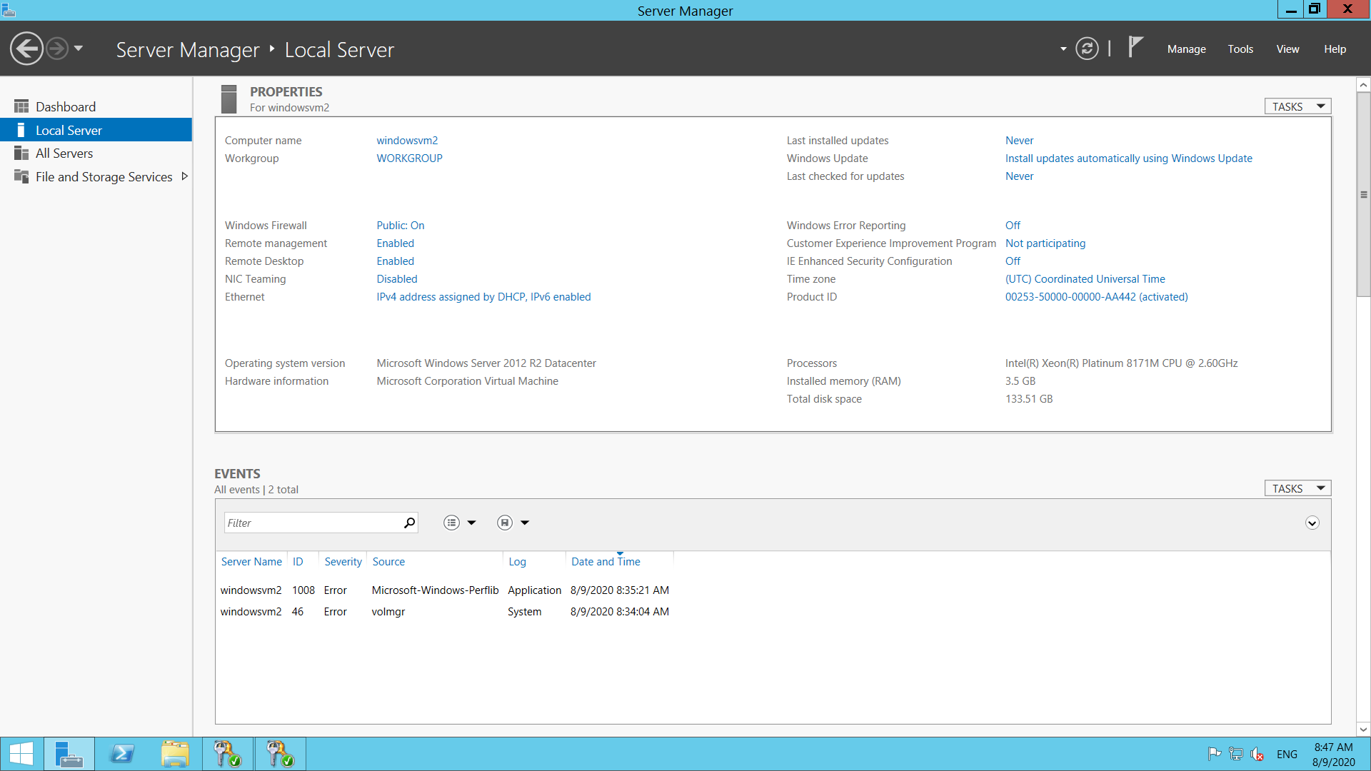

Right now, disk is not mounted here

